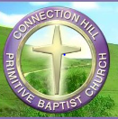
Connection Hill Scholarship Community Service Form
Date & Time  (start/Finish) | Organization | Description of services (activities) | Signature of Organizer and CBR
June 10, 2016 | Nashville Mission | Served food to homeless population. Prayed for individual who recently lost job and who is on drugs. | TBA
Total semester hours: 15

